N | Name | Code | quantity, | size | description | price, EUR
N | Name | Code | pcs | size | description
 | Villeroy & Boch |  |  | 485 x 400
1 | TWIST Undermount | 5A101901 | 439 | 485 x 400 |  | € | 34,20
 |  |  |  | mm |  | € | 34,20
 | sink with overflow |  |  | mm
 | Villeroy & Boch
2 | Architectura Oval | 5A191701 | 681 | 432 x 356 |  | € | 38,40
2 | Undermount | 5A191701 | 681 | mm |  | € | 38,40
 | Bathroom Sink
3 | Villeroy & Boch LA | 6124AU-R1 | 35 | 1000 x 489 |  | € | 398,40
3 | BELLE Wash Basin | 6124AU-R1 | 35 | mm |  | € | 398,40
 | Villeroy & Boch | UBA157ARA2 |  | 1500 x 700
4 | Architectura | UBA157ARA2 | 2 | 1500 x 700 |  | € | 221,40
4 | Architectura | V-01 | 2 | mm |  | € | 221,40
 | Rectangular bath | V-01 |  | mm
5 | Villeroy & Boch | 613670 R1 | 4 | 700 x 550 |  | € | 80,40
5 | Subway washbasin | 613670 R1 | 4 | mm |  | € | 80,40
 | Villeroy & Boch
6 | Architectura | 5A191501 | 67 | 380 x 315 |  | € | 38,40
6 | Undercounter | 5A191501 | 67 | mm |  | € | 38,40
 | washbasin
 | Villeroy & Boch |  |  | 584 x 464
7 | Strada Drop-In | 5A012301 | 28 | 584 x 464 |  | € | 129,00
 |  |  |  | mm |  | € | 129,00
 | Bathroom Sink |  |  | mm
 | Villeroy & Boch |  |  | 380 x 315
8 | Twist Under Counter | 5A101501 | 243 | 380 x 315 |  | € | 47,40
 |  |  |  | mm |  | € | 47,40
 | Wash Basin |  |  | mm
9 | Villeroy & Boch Loop | UBA180LFO7 | 8 | 1800 x 800 |  | € | 547,20
9 | and friends bath | PDFV-01 | 8 | mm |  | € | 547,20
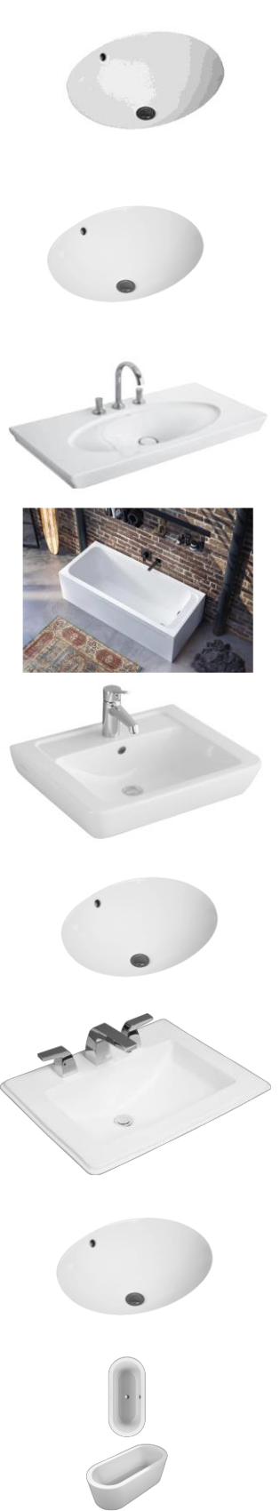
10 | Villeroy & Boch | UBQ180NEU7 | 3 | 1771 x 771 |  | € | 984,60
10 | Nexus Oval bath | V-01 | 3 | mm |  | € | 984,60
 | Villeroy & Boch | UBQ180SQE7 |  | 1800 x 800
11 | Squaro Edge 12 Free- | UBQ180SQE7 | 15 | 1800 x 800 |  | € | 1 186,80
 | standing bath | PDV-01 |  | mm
 | Villeroy & Boch Loop | UBA180LFS7 |  | 1800 x 800
12 | & Friends Oval bath | UBA180LFS7 | 4 | 1800 x 800 |  | € | 990,60
12 | & Friends Oval bath | PDFV-01 | 4 | mm |  | € | 990,60
 | SQUARE Duo | PDFV-01 |  | mm
13 | Villeroy & Boch Loop | UBA180LFS7 | 1 | 1800 x 800 |  | € | 340,80
13 | & Friends Oval bath | V-01 | 1 | mm |  | € | 340,80
14 | Villeroy&Boch Loop | 516350R1 | 14 |  |  | € | 151,20
14 | Friends | 516350R1 | 14 |  |  | € | 151,20
 | Villeroy And Boch
15 | 613660R1 Subway | 613660R1 | 43 |  |  | € | 67,20
15 | Washbasin (Basin | 613660R1 | 43 |  |  | € | 67,20
 | Only) In White Al
16 | Villeroy Boch OMNIA | 517565 R | 7 | 650 x 500 |  | € | 33,60
 | architectura Basin |  |  | mm
17 |  | 5145501 | 1 |  |  | € | 133,80
18 | Villeroy&Boch Loop | 516160R1 | 2 |  |  | € | 168,00
18 | Friends basin | 516160R1 | 2 |  |  | € | 168,00
19 |  | SVW1191350 | 229 |  |  | € | 167,40
19 |  | 031A | 229 |  |  | € | 167,40
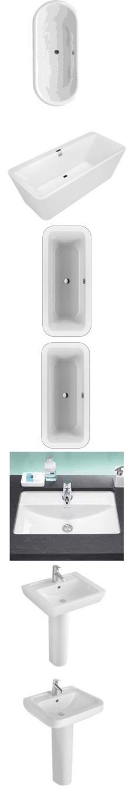
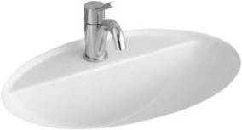
20 |  | SVW1191603 | 1 |  |  | € | 75,60
20 |  | 1A | 1 |  |  | € | 75,60
21 |  | SVW111347A | 175 |  |  | € | 96,00
21 |  | 131A | 175 |  |  | € | 96,00
22 |  | SVW1336360 | 2 |  |  | € | 80,40
22 |  | 031A | 2 |  |  | € | 80,40
23 | VITROMEX Lavabo | SVW111347A | 306 |  |  | € | 96,00
23 | impala 4" hueso | 131A | 306 |  |  | € | 96,00
24 |  | pedestal | 147 |  |  | € | 35,50
24 |  | impala hueso | 147 |  |  | € | 35,50
25 |  | UBPA18008P | 1
25 |  | D7-01 | 1
26 |  |  |  | 16 august 2022
 | Villeroy & Boch VB |  |  | 650x220x51
27 | Subway 45 Compact | 331200i5 | 5 | 650x220x51 |  | € | 178,13
 |  |  |  | 0mm |  | € | 178,13
 | rectangle Sand c+ |  |  | 0mm
28 | Villeroy & Boch Siluet | 33350FTR | 1 | 88x49 cm |  | € | 362,85
 | 50 flat Timber
29 | Villeroy & Boch | 6321 90 01 | 135 | 50x40x17cm |  | € | 530,00
29 | Kitchen Butler Sink | 6321 90 01 | 135 | 50x40x17cm |  | € | 530,00
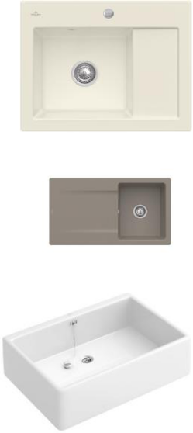
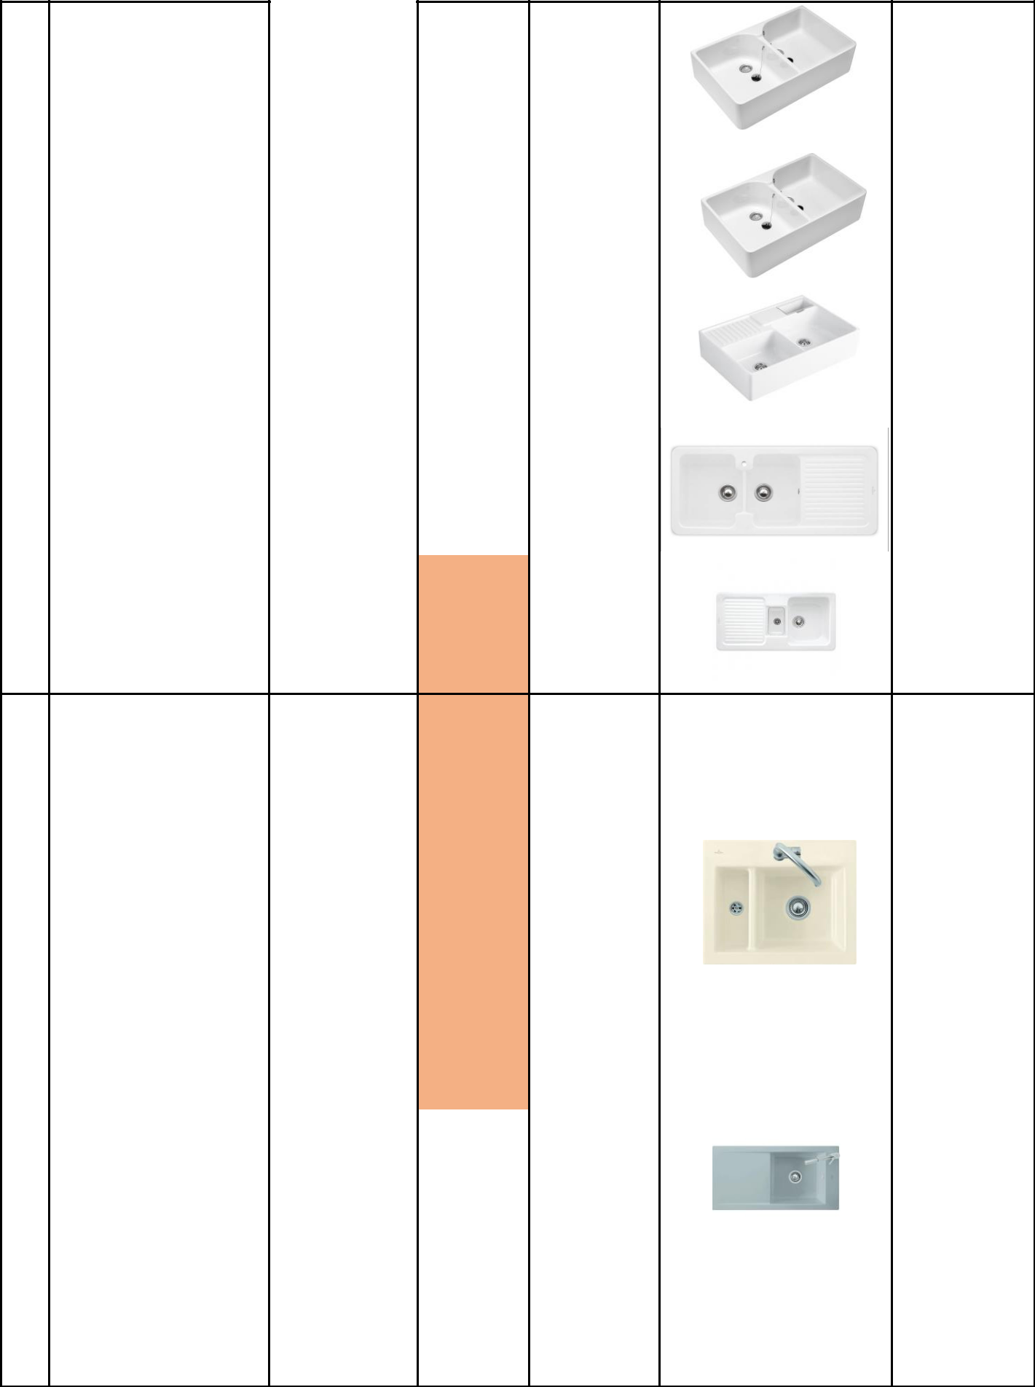 | Villeroy & Boch
30 | O.novo Dubbele | 6331 00 t1 | 5 | 79,5x51x22 | € | 339,00
30 | spoelbak Wit Alpin | 6331 00 t1 | 5 | cm | € | 339,00
 | AntiBac
 | Villeroy & Boch
 | O.Novo umywalka |  |  | 89,5x22x55
31 | podwójna z | 633200T1 | 3 | 89,5x22x55 | € | 380,00
 |  |  |  | cm | € | 380,00
 | przelewem Weiss |  |  | cm
 | Alpin AntiBac
 | Villeroy & Boch VB
33 | Spülstein | 632300i5 | 1 | 895x220x63 | € | 377,00
33 | Doppelbecken | 632300i5 | 1 | 0mm | € | 377,00
 | Rechteck Sand C+
 | Villeroy & Boch |  |  | 1160 x 510
34 | Condor 80 Spüle | 674600TR | 1 | 1160 x 510 | € | 398,00
 |  |  |  | mm | € | 398,00
 | Timber Cer amicplus |  |  | mm
35 | Villeroy&Boch | 6759 00 i2 | 2 | 1000x510x2 | € | 303,00
35 | Condor cappucino | 6759 00 i2 | 2 | 00 mm | € | 303,00

36 | GA 80 SINK W/O ACC S | 67520073 | 7 |  | € | 186,00
 | Villeroy & Boch
37 | Subway 60 XM flat | 6780 0f tr | 1 | 585x475mm | € | 256,00
 | 67800 Timber
38 | Laola 50 by Villeroy & | 6778 00 sl | 1 | 900 x 510 | € | 252,00
 | Boch |  |  | mm
 | Villeroy and Boch |  |  | 1000x510m
39 | rectangle La Rose | 679000KW | 6 | 1000x510m | € | 335,00
 |  |  |  | m | € | 335,00
 | CeramicPlus |  |  | m
 | villeroy & Boch
40 | Timeline 60 flat | 67900FTR | 4 | 965x475mm | € | 328,00
 | Timber CeramicPlus |  |  | 965x475mm

 | Villeroy und Boch
41 | rectangle Timber | 679100TR | 13 | 800x510mm |  | € | 240,00
 | CeramicPlus
 | Villeroy & Boch VB
42 | Einbauspüle Timeline | 679100KW | 7 | 800x |  | € | 240,00
42 | aus Keramik La Rose | 679100KW | 7 | 510mm |  | € | 240,00
 | CeramicPlus
 | Villeroy and Boch |  |  | 800x
43 | rectangle Steam | 679100sm | 8 | 800x |  | € | 240,00
 |  |  |  | 510mm |  | € | 240,00
 | CeramicPlus |  |  | 510mm
 | Villeroy and Boch |  |  | 800x
44 | rectangle cappucino | 679100i4 | 8 | 800x |  | € | 240,00
 |  |  |  | 510mm |  | € | 240,00
 | CeramicPlus |  |  | 510mm
 | Villeroy and Boch
45 | rectangle Snow | 679100KG | 12 | 800x510mm |  | € | 240,00
 | White C +
 | Villeroy & Boch 45
46 | flat Chromite C | 6791 0f kg | 6 | 765x475mm |  | € | 248,00
 | Snow white
47 | Villeroy&Boch | 6791 0f fu | 14 | 765 x 475 |  | € | 248,00
47 | Timeline 45 | 6791 0f fu | 14 | mm |  | € | 248,00
 | Villeroy & Boch |  |  | 765 x 475
48 | Timeline 45 Flat | 67910fs5 | 2 | 765 x 475 |  | € | 248,00
 |  |  |  | mm |  | € | 248,00
 | Ebony |  |  | mm
49 | Villeroy&Boch | 67910fr1 | 10 | 765 x 475 |  | € | 248,00
49 | Timeline 45 | 67910fr1 | 10 | mm |  | € | 248,00
50 | Villeroy&Boch | 67910FKR | 3 | 765 x 475 |  | € | 248,00
50 | Timeline 45 Cream | 67910FKR | 3 | mm |  | € | 248,00
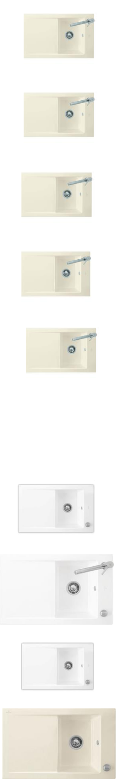
51 | Villeroy&Boch | 67910f i4 | 12 | 800x510mm |  | € | 248,00
51 | Timeline graphite | 67910f i4 | 12 | 800x510mm |  | € | 248,00
 | Villeroy and Boch
52 | rectangle La Rose | 6791 00 kw | 8 | 800x510mm |  | € | 248,00
 | CeramicPlus
53 | RT 90 SINK W/O ACC G | 6793 00 i4 | 1 |  |  | € | 419,00
54 | V&B Flavia 45 | 3306 00 kg | 3 |  |  | € | 330,00
55 | Villeroy & Boch | 3307 00 kw | 4 | 90x51 cm |  | € | 280,00
55 | Timeline 50 La Rose | 3307 00 kw | 4 | 90x51 cm |  | € | 280,00
56 |  | 3390 00 73 | 6 |  |  | € | 150,00
58 | LE DVW 130CM WEISS A | 5881 13 01 | 2 |  |  | € | 185,00
59 |  | 6022 10 r1 | 12 |  |  |  | ?
 | Washbasin for
60 | furniture Villeroy & | 5133 aj 01 | 8 | 100x47 cm |  | € | 330,00
60 | Boch Memento , | 5133 aj 01 | 8 | 100x47 cm |  | € | 330,00
 | without tap hole
61 | Villeroy & Boch | 5133 ck s0 | 6 | 1200 x 470 |  | € | 380,00
61 | Memento | 5133 ck s0 | 6 | mm |  | € | 380,00
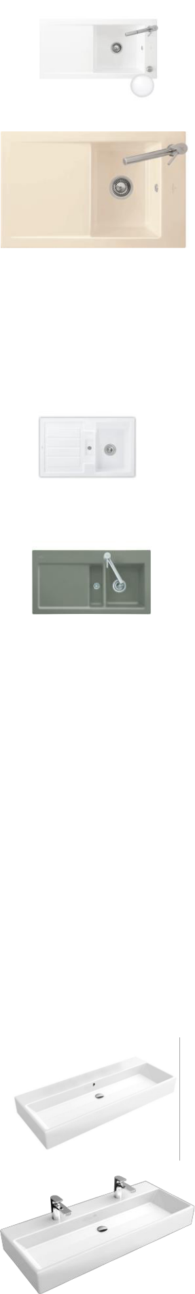
62 | Villeroy & Boch | 5133 c5 r2 | 1 | 1200 x 470 |  | € | 360,00
62 | Memento | 5133 c5 r2 | 1 | mm |  | € | 360,00
 | Washbasin for |  |  | 1200 x 470
63 | furniture Villeroy & | 5133 ch s0 | 1 | 1200 x 470 |  | € | 360,00
 |  |  |  | mm |  | € | 360,00
 | Boch Memento |  |  | mm
64 | Villeroy & Boch | 5133p101 | 1 | 1200 x 470 |  | € | 380,00
64 | Memento | 5133p101 | 1 | mm |  | € | 380,00
65 | Villeroy & Boch | 5133a5u7 | 1 | 1000x470m |  | € | 330,00
65 | Waschtisch | 5133a5u7 | 1 | m |  | € | 330,00
 | MEMENTO
66 | Villeroy & Boch | 5133A3S3 | 1 | 1000x470m |  | € | 370,00
66 | Memento Waschtisch | 5133A3S3 | 1 | m |  | € | 370,00
67 | Villeroy & Boch | 5133a5s3 | 1 | 1000x470m |  | € | 410,00
67 | Memento | 5133a5s3 | 1 | m |  | € | 410,00
68 | Villeroy & Boch | 5133al 01 | 1 | 1000x470m |  | € | 330,00
68 | Memento | 5133al 01 | 1 | m |  | € | 330,00
69 | Villeroy & Boch | 5133 a5 01 | 1 | 1000x470m |  | € | 360,00
69 | Memento | 5133 a5 01 | 1 | m |  | € | 360,00
 | Villeroy & Boch
70 | Waschtisch | 5133A601 | 3 | 1000x470m |  | € | 370,00
70 | MEMENTO ohne | 5133A601 | 3 | m |  | € | 370,00
 | Hahnloch weiss
71 | Villeroy&Boch | 5133c1r2 | 5 | 1000x470m |  | € | 360,00
71 | Memento 5133C1R2 | 5133c1r2 | 5 | m |  | € | 360,00
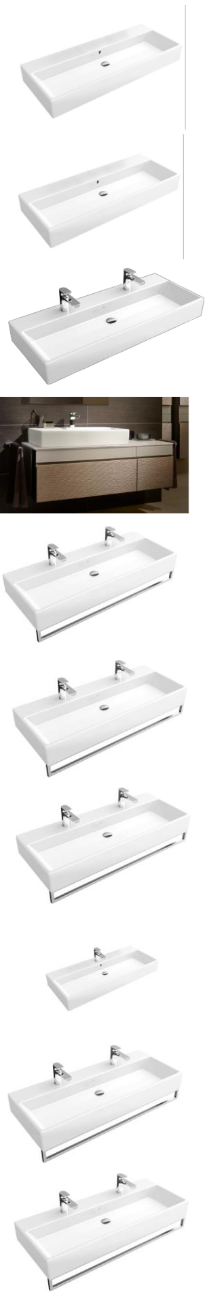
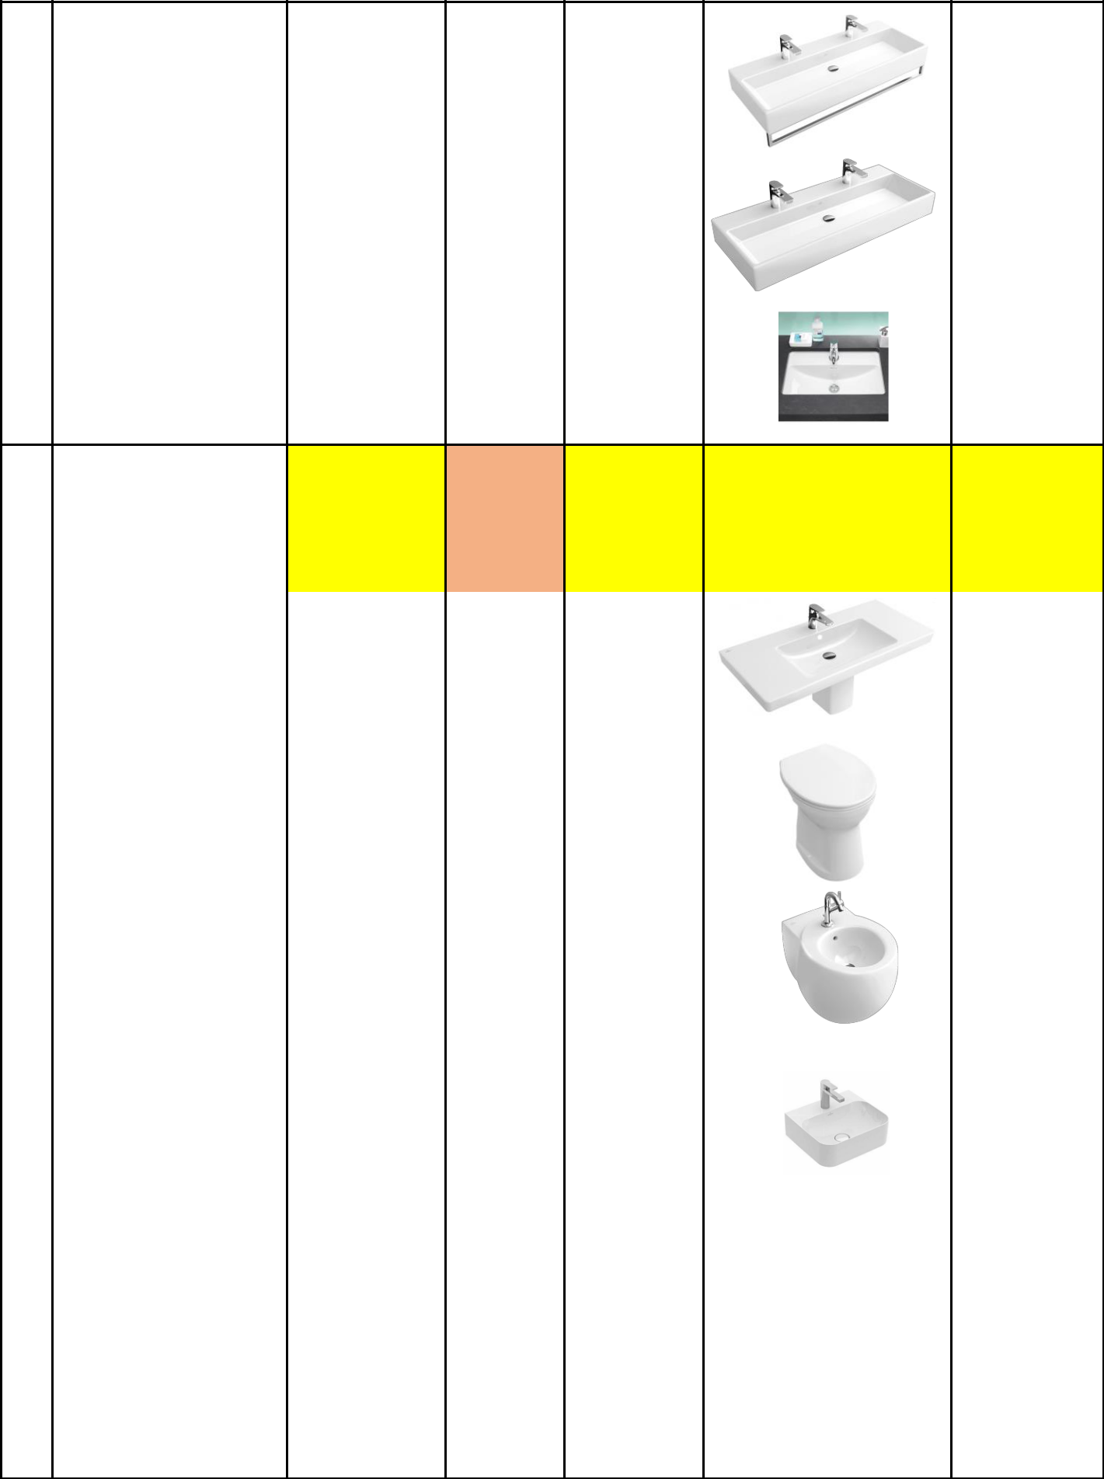  72 | Villeroy & Boch | 5133 a1 r1 | 1 | 1000x470m | € | 360,00
 | Memento | 5133 a1 r1 | 1 | m | € | 360,00
73 | Villeroy & Boch | 5133 af 01 | 5 | 1000 x 470 | € | 380,00
73 | Memento | 5133 af 01 | 5 | mm | € | 380,00
75 | Villeroy&Boch Loop | 51636101 | 6 | 61,5x39 cm | € | 301,00
75 | Friends

76 | ITY WASHBASIN 80 CM | 587980 01 | 85
77 | Villeroy & Boch | 7175 a1 r1 | 6 | 100x47 cm | € | 293,00
77 | Subway 2.0
78 | Villeroy & Boch O. | 7619 10 t1 | 1 | 355 x 455 | € | 92,00
78 | Novo AntiBac | 7619 10 t1 | 1 | mm | € | 92,00
79 | Villeroy & Boch Aveo | 741100r2 | 3 | 400 x 590 | € | 556,00
 | new generation |  |  | mm
 | Villeroy Boch Finion |  |  | 430 x 390
80 | (star white | 4364 4l r2 | 5 | 430 x 390 | € | 203,00
 |  |  |  | mm | € | 203,00
 | ceramicplus) |  |  | mm
81 |  | 4154 c401 | 68
82 |  | 4154 a501 | 18

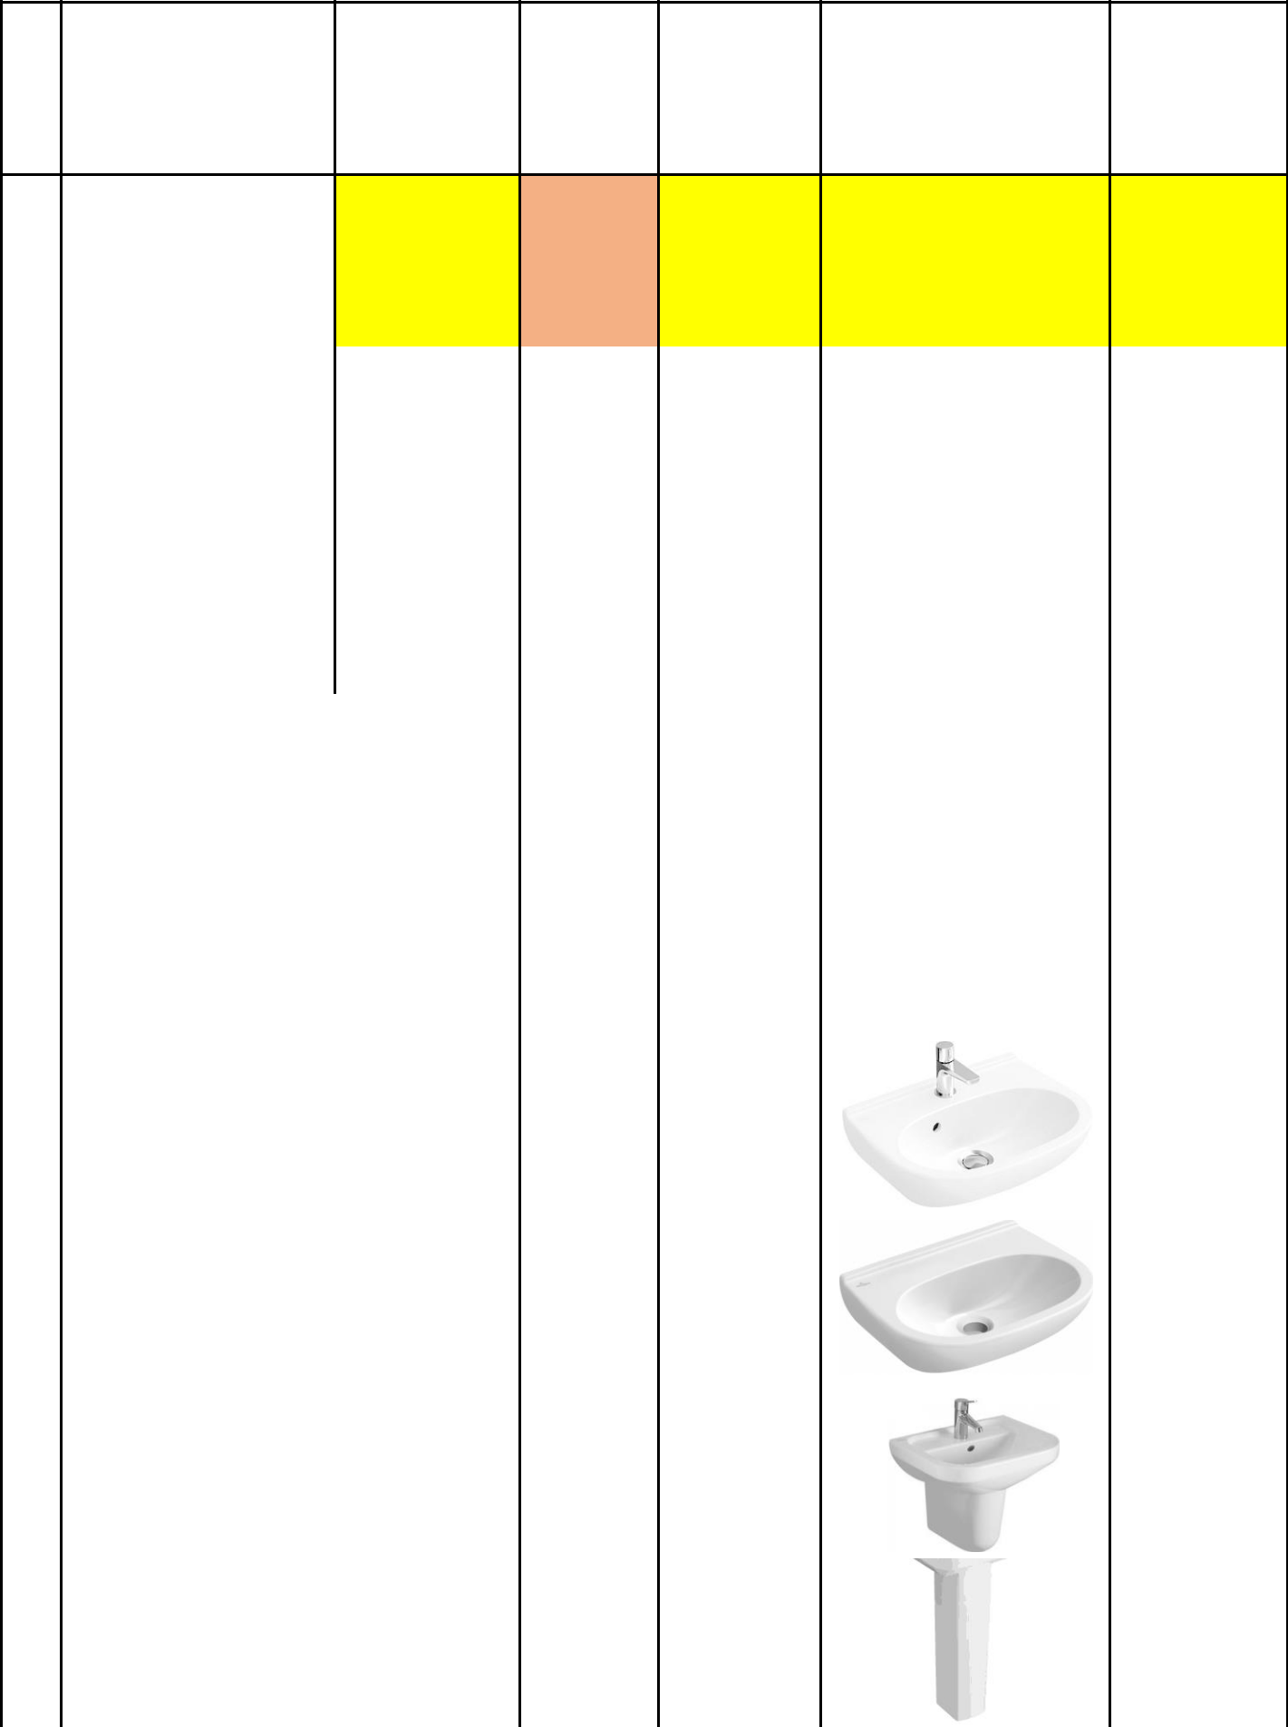  83 | 4154 c501 | 162

84 | ANITY WASHBASIN 100C | 4154a201 | 36
85 |  | 4154c101 | 32
86 | VANITY WASHBASIN 120 | 4154c5r1 | 4
87 | VANITY WASHBASIN 80 | 4154 80 01 | 145
88 |  | 2 Lap 60*120 | 123
88 |  | (43.20 m2) | 123
89 | Villeroy & Boch | 536047r1 | 2 | 45x35cm | € | 57,00
89 | O.novo compact
90 | Villeroy & Boch | 536048t1 | 2 | 45x35cm | € | 75,00
90 | O.novo Compact
 | Villeroy&Boch Omnia
91 | Architectura | 537345r1 | 1 | 45x35cm | € | 58,00
 | 537345R1
 | Villeroy & Boch,
92 | Subway 2.0 Sloup | 5243 00 r3 | 1 | 45x35cm | € | 125,00
92 | ,Pergamon
 | CeramicPlus

93 |  | 5243 00 r1 | 1 |  |  | € | 125,00
94 | Villeroy & Boch Loop | 514900 r2 | 6 | 380 x 380 |  | € | 203,00
94 | & Friends | 514900 r2 | 6 | mm |  | € | 203,00
 | Villeroy & Boch
95 | O.novo washbasin | 411958 t2 | 1 | 560x 550 |  | € | 190,00
95 | Vita Blanc AntiBac | 411958 t2 | 1 | mm |  | € | 190,00
 | CeramicPlus
96 | Villeroy&Boch | 514040r2 | 1 | 455x 455 |  | € | 60,00
96 | Loop&Friends | 514040r2 | 1 | mm |  | € | 60,00
97 | Villeroy & Boch | 5133 5F MD | 1 | 500 x 420 |  | € | 132,00
97 | Memento | 5133 5F MD | 1 | mm |  | € | 132,00
98 | Villeroy & Boch | 513350 md | 1 | 500 x 420 x |  | € | 120,00
98 | Memento | 513350 md | 1 | 140 mm |  | € | 120,00
99 | Vigour Clivia | 41918301 | 1 | 55 cm |  | € | 60,00
100 | TY WASHBASIN 120CM | 4a03c101 | 1
 | Villeroy Boch Hand
101 | Rectangle Bathroom | 5333U0R1 | 5 | 400 x 260 |  | € | 173,00
 | Sink White Alpin |  |  | mm
 | Ceramic Plus
 | Villeroy and Boch
102 | rectangle Stone | 670200RW | 3 | 545x440mm |  | € | 200,00
 | White C +
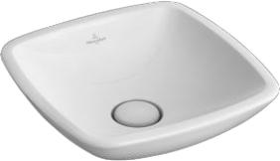
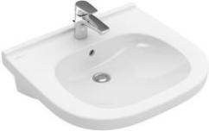
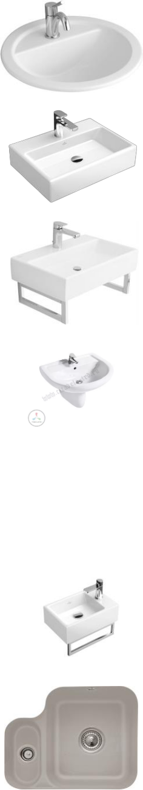
103 | Villeroy&Boch | 6707 00 l5 | 1 | 260x440mm |  | € | 110,00
103 | Cisterna 26 | 6707 00 l5 | 1 | 260x440mm |  | € | 110,00
104 | Villeroy&Boch | 670700s3 | 1 | 260x440mm |  | € | 110,00
104 | Cisterna 26 edelweiss | 670700s3 | 1 | 260x440mm |  | € | 110,00
105 | DERMOUNT 19" MATT | 6706 fo s5 | 8 |  |  | € | 270,00
106 |  | 58851001 | 25
107 | Villeroy & Boch Loop | 7186 d1 r3 | 1 | 530 x 380 |  | € | 154,00
 | and Friends |  |  | mm
 | ARTO
108 | Handwaschbecken | 433745 r1 | 1 | mm
108 | A18 mit CeramicPlus | 433745 r1 | 1 | 450x380mm
 | Typ 433745R1 weiß
109 | PORA WDOWN WC FOR | 4644 r0r1 | 10
110 |  | 4644r001 | 17
111 |  | 4653r001 | 4
 | Villeroy & Boch V&B
 | Festival Stand-WC
112 | Tiefspüler Abgang | 7f660101 | 12 |  |  | € | 28,00
 | senkrecht, weiß
 | 7F620101
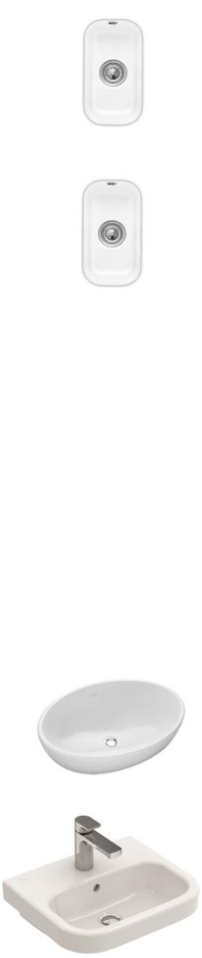
 | Villeroy and Boch
113 | Aveo New | 413151R1 | 1 | 500 x 405 |  | € | 175,00
113 | Generation Oval | 413151R1 | 1 | mm |  | € | 175,00
 | Washbasin
114 | Villeroy & Boch Finion | 41688ls3 | 5 | 800 x 470 |  | € | 450,00
 |  |  |  | mm |  | € | 450,00
115 | Villeroy & Boch | 4164 ab r2 | 2 | 1000 x 500 |  | € | 420,00
115 | Finion 4164ABR2 | 4164 ab r2 | 2 | mm |  | € | 420,00
 | Villeroy & Boch |  |  | 1000 x 500
116 | Rectangular | 4164 a0 r2 | 3 | 1000 x 500 |  | € | 420,00
 |  |  |  | mm |  | € | 420,00
 | Washbasin |  |  | mm
 | Villeroy & Boch |  |  | 1200 x 500
117 | Rectangular | 4164 c1 r2 | 2 | 1200 x 500 |  | € | 510,00
 |  |  |  | mm |  | € | 510,00
 | Washbasin |  |  | mm
118 | VILLEROY & BOCH | 5660d001 | 1 | 56 x36x112 |  | € | 120,00
 | O.NOVO
119 | Villeroy & Boch Verity | 51036001 | 48 | 600 x 470 |  | € | 45,00
 | 51036001 |  |  | mm
120 |  | 5708 11 r1 | v
121 |  | 57081101 | 14
 | Villeroy & Boch |  |  | 550 x 460
122 | Villeroy & Boch O. | 41556501 | 141 | 550 x 460 |  | € | 80,00
 |  |  |  | mm |  | € | 80,00
 | Novo |  |  | mm
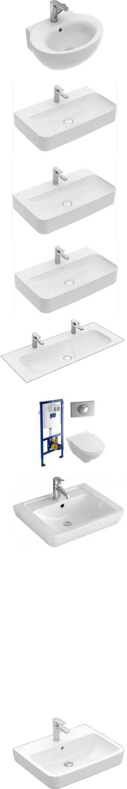
123 | PURE WWC | 58861001 | 4
 | Villeroy & Boch
124 | Lifetime Plus shower | 6223n3tp 06a | 3 | 120 x 80 x |  | € | 196,00
 | tray 6223N3TP, | 05 |  | 3.5 cm
 | taupe with non-slip
 | Villeroy & Boch
125 | Lifetime Plus shower | 6223b3tp | 8 | 80 x 80 x |  | € | 120,00
 | tray 6223B3TP , | 23a 20 |  | 3.5 cm
 | taupe with non-slip
 | Villeroy & Boch
 | Subway Infinity | 6231t3vp |  | 140 x 80 x 4
126 | shower tray | 6231t3vp | 1 | 140 x 80 x 4 |  | € | 157,00
126 | shower tray | c201a60 | 1 | cm, |  | € | 157,00
 | 6231T3TP, taupe | c201a60 |  | cm,
 | with anti-slip
127 | Villeroy & Boch | 6228f4vpc0 | 1 | 900 mm, |  | € | 157,00
127 | Subway Infinity, | 01a60 | 1 | 900 mm |  | € | 157,00
 | Villeroy & Boch
128 | Subway Infinity | 623214TP | 1 | 150 x 90 x 4 |  | € | 278,00
128 | shower tray, , taupe | 623214TP | 1 | cm |  | € | 278,00
 | with non-slip
 | Villeroy & Boch
129 | Subway Infinity | 623233TP | 1 | 150 x 80 x 4 |  | € | 278,00
129 | shower tray, , taupe | 623233TP | 1 | cm |  | € | 278,00
 | with anti-slip
 | Villeroy & Boch
130 | Lifetime Plus shower | 6223N3TP | 3 | 120 x 80 x |  | € | 196,00
130 | tray, taupe with non- | 6223N3TP | 3 | 3.5 cm |  | € | 196,00
 | slip
 | Villeroy & Boch
131 | Subway Infinity | 623245TP | 3 | 160 x 100 x |  | € | 290,00
131 | shower tray , taupe | 623245TP | 3 | 4 cm |  | € | 290,00
 | with non-slip
 | Villeroy & Boch
132 | Subway Infinity | 6231S4TP | 3 | 140 x 90 x 4 |  | € | 216,00
132 | shower tray , taupe | 6231S4TP | 3 | cm |  | € | 216,00
 | with anti-slip

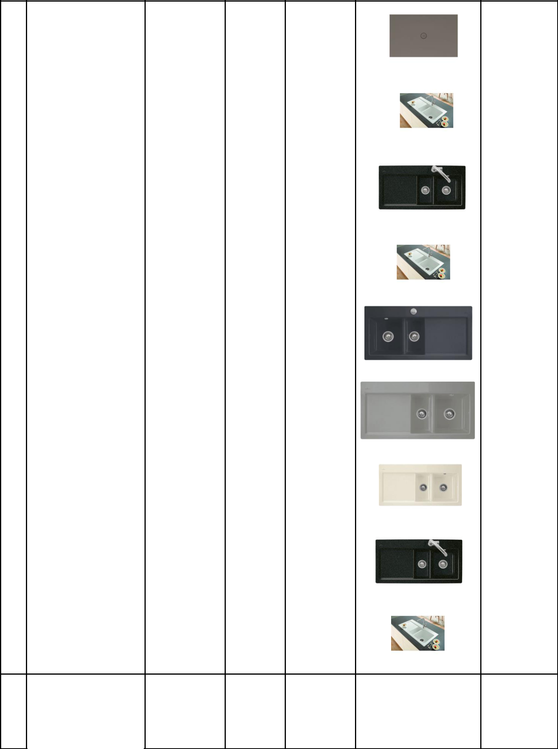 | Villeroy & Boch
133 | Subway Infinity | 6230N4TP | 3 | 120 x 90 x 4 | € | 196,00
133 | shower tray , taupe | 6230N4TP | 3 | cm | € | 196,00
 | with non-slip
 | Villeroy & Boch
 | Subway 60XR 1.5 |  |  | 1000x510m
134 | Bowl & Drainer | 672000 r1 | 23 | 1000x510m | € | 257,00
 |  |  |  | m | € | 257,00
 | Ceramic Kitchen Sink |  |  | m
 | White Ceramic
 | Villeroy & Boch VB
135 | Einbauspüle Subway | 672000rw | 1 | 1000x510m | € | 259,00
 | 60 XR Rechteck |  |  | m
 | Stone White C+
 | Villeroy & Boch
136 | Subway 60 XR Spüle | 6720 00 kg | 1 | 1000 x 5 10 | € | 329,00
 | Becken links Snow |  |  | mm
 | White Ceramicplus
 | Villeroy & Boch |  |  | 1000 x 5 10
137 | Subway 60 XR | 6721 00 i4 | 25 | 1000 x 5 10 | € | 257,00
 |  |  |  | mm | € | 257,00
 | Graphite |  |  | mm
 | Villeroy & Boch
138 | flächenb Spüle | 67210fkd | 1 | 965x475mm | € | 275,00
138 | Subway 60 XR flat
 | 67210F C+ Fossil
 | Subway 60 XR flat
139 | Cream Ceramicplus | 6721 0f kr | 1 | 965 x 475 | € | 275,00
 | Crema C+ |  |  | mm
 | VILLEROY & BOCH
 | Villeroy & Boch VB
140 | Einbauspüle Subway | 672100rw | 1 | 1000x510m | € | 257,00
 | 60 XR Rechteck |  |  | m
 | Stone White C+
 | Villeroy & Boch
141 | Subway 60 XR Spüle | 6721 00 kg | 7 | 1000 x 5 10 | € | 257,00
141 | Becken rechts Snow | 6721 00 kg | 7 | mm | € | 257,00
 | White Ceramicplus

142 60 XR SINK W/O ACC W | 6720 00 01 | 9

 | EVIER SUBWAY |  |  | 1000x510
143 | PURE 60XL | 67182073 | 2 | 1000x510 |  | € | 227,00
 |  |  |  | mm |  | € | 227,00
 | VILLEROY & BOCH |  |  | mm
 | Villeroy & Boch |  |  | 1000х510х2
144 | Subway 60 XL | 6719 00 s3 | 5 | 1000х510х2 |  | € | 210,00
 |  |  |  | 20 mm |  | € | 210,00
 | Edelweiss |  |  | 20 mm
 | Villeroy und Boch |  |  | 1000x510m
145 | rectangle La Rose | 677000KW | 3 | 1000x510m |  | € | 315,00
 |  |  |  | m |  | € | 315,00
 | CeramicPlus |  |  | m
 | Villeroy & Boch
146 | Subway 50 flat Spüle | 67730FKD | 6 | 880 x 475 |  | € | 270,00
 | Becken links Fossil |  |  | mm
 | Ceramicplus
 | Villeroy & Boch
 | Subway 50 flat Spüle |  |  | 880 x 475
147 | Becken links Fossil | 67730fi4 | 1 | 880 x 475 |  | € | 270,00
 |  |  |  | mm |  | € | 270,00
 | Ceramicplus |  |  | mm
 | Graphite
 | Villeroy & Boch
148 | Subway 50 flat link | 67730FRW | 6 |  |  | € | 270,00
 | Ceramicplus
 | Villeroy & Boch
149 | Subway 50 flat Spüle | 67730FR1 | 5 | 880 x 475 |  | € | 270,00
 | Becken link weiss |  |  | mm
 | Alpin Ceramicplus
 | Villeroy and Boch
150 | rectangle Chromite | 677300J0 | 22 | 915x510mm |  | € | 256,00
 | CeramicPlus
 | Villeroy and Boch
151 | rectangle La Rose | 677300KW | 11 | 915x510mm |  | € | 256,00
 | CeramicPlus
 | Villeroy and Boch
152 | rectangle White Pearl | 677300KT | 4 | 915x510mm |  | € | 256,00
 | C +
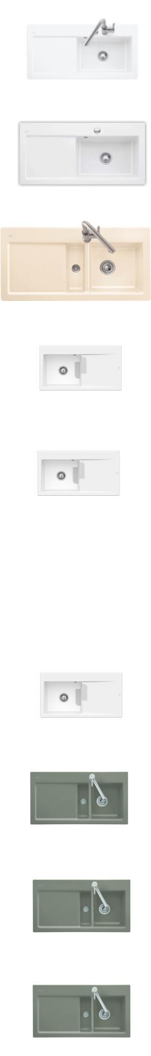
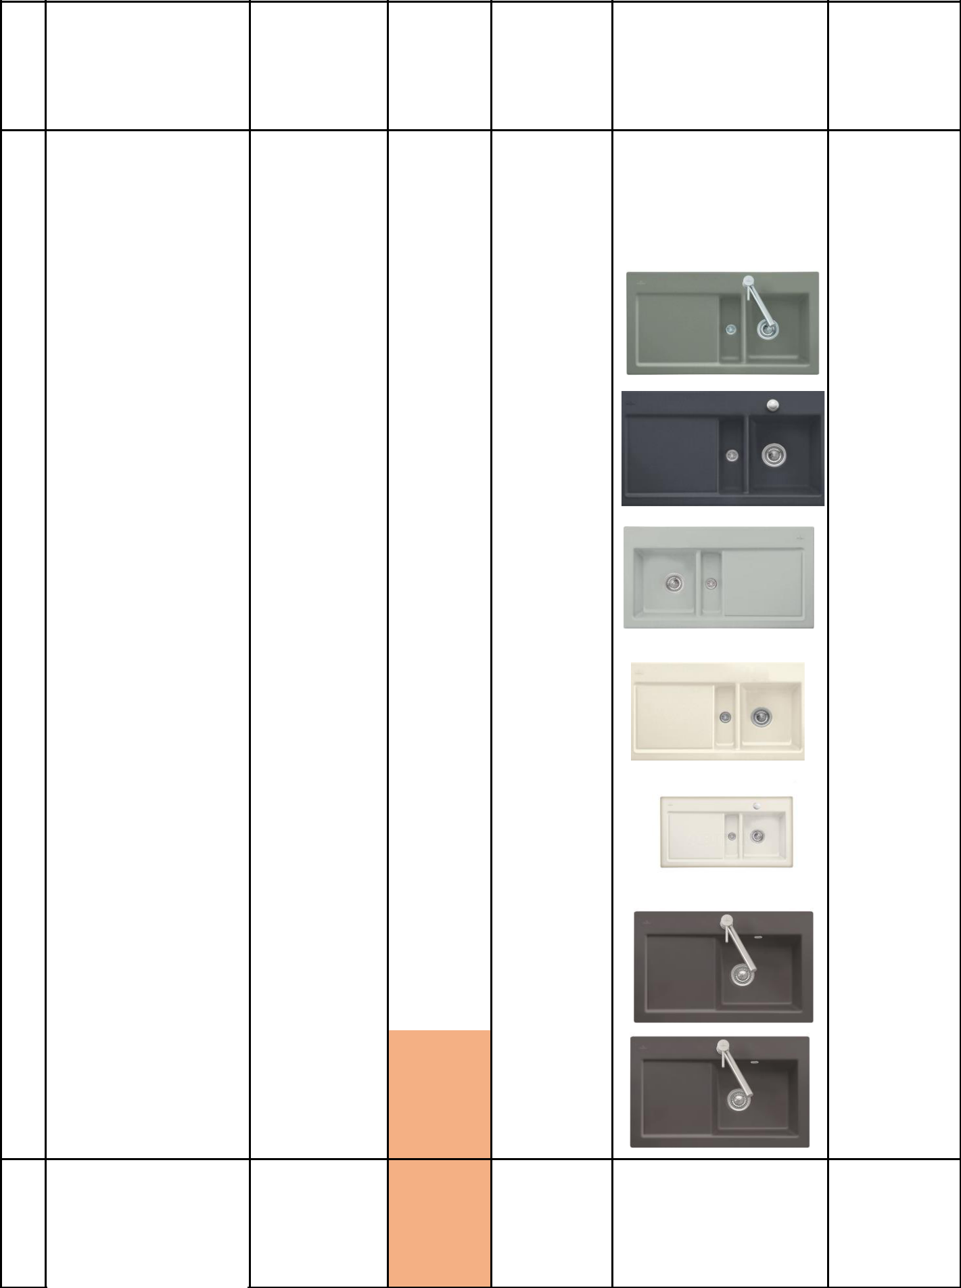
153 | 6713 0f rw | 7 | € | 225,00

154 UBWAY 50 SINK W/O AC |  | 6713 00 i5 | 6 |  | € | 225,00
 | Villeroy & Boch
155 | Subway 50 flat Spüle | 67130FJ0 | 5 | 880 x 475 | € | 260,00
 | Becken rechts |  |  | mm
 | Chromit Ceramicplus
 | Villeroy & Boch
156 | Subway 50 flat | 67130Fi4 | 2 | 880x475mm | € | 260,00
 | Rechteck Graphite C+ |  |  | 880x475mm
 | Villeroy & Boch
157 | Subway 50 flat | 67130fkd | 7 | 880x475mm | € | 260,00
 | Fossil C+ |  |  | 880x475mm
 | Villeroy & Boch
158 | Subway 50 flat | 67130fkr | 5 | 880x475mm | € | 260,00
 | Cream C+ |  |  | 880x475mm
 | Villeroy & Boch
159 | flächenbündige Spüle | 67130FFU | 4 | 880x475mm | € | 260,00
 | Subway 50 flat
 | Rechteck Ivory C+
 | Villeroy and Boch
160 | rectangle La Rose | 671400KW | 6 | 780x510mm | € | 233,00
 | CeramicPlus
 | Villeroy and Boch
161 | rectangle La Rose | 671400i2 | 1 | 780x510mm | € | 233,00
161 | CeramicPlus
 | cappucino

162

UBWAY 50 SINK W/O AC

6773 00 l5

1

- 256,00


163

U-CNTER SINK W/O AC

3325 00 26

1


- 220,00

